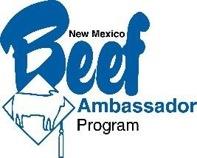
2022 NEW MEXICO BEEF AMBASSADOR COMPETITION
Entry Deadline May 31st, 2022
The New Mexico Beef Ambassador Program, managed by the New Mexico CowBelle organization, strives to provide an opportunity for youth to educate consumers and students about beef nutrition, food safety and stewardship practices of the beef industry. Beef Ambassadors tell their beef production story to consumers and students through promotion, education, media and the online environment.
June 13th, 2022 – Ruidoso

In conjunction with the NMCB Mid-Year Meeting
~ Contestants must be age 16-20 by entry date ~

Three Member New Mexico Beef Ambassador Team
During their year of service to the NM CowBelles, the Beef Ambassador team will travel throughout the state to promote the beef industry through educational programs, presentations, special events and social media.

New Mexico Beef Ambassador Contest

Attire
Professional attire befitting a presentation before a group.

Speech, Presentation, or Demonstration
Each contestant will prepare and present a 5-7 minute speech, PowerPoint presentation, or demonstration factually based on the following beef industry topic:

TOPIC: “Ranchers the Original Environmentalists!”

Beef Industry Resources:
Websites: www.factsaboutbeef.org, www.beefnutrition.org, www.beefitswhatsfordinner.org, www.beeffrompasturetoplate.org, www.agweb.com/livestock/beef/news, www.beef.org, www.nmbeef.com, and www.nmagriculture.org

Print Media: NM Stockman, Drover’s Journal, NMSU Cooperative Extension Publications,
Beef Magazine, Progressive Cattleman, etc.

Interview
Each contestant will be interviewed by a panel of judges who will ask questions of the contestant to
further assess the individual’s ability to become the next youth spokesperson for the beef industry.

