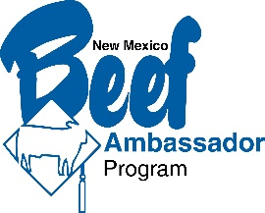
New Mexico Beef Ambassador Contest Entry Form

Entry Deadline: May 31, 2022
NAME: ______________________________________________________________
ADDRESS: ___________________________________________________________
CITY, STATE, ZIP: ____________________________________________________
CELL PHONE #: _____________________________________________________
E-MAIL:____________________________ SCHOOL/COLLEGE______________
- Ages 16-20 by May 31, 2022
- Include a head shot and a short biography.
  - Include your “Beef Story” and why you would like to be a Beef Ambassador
- Attach your meme/infographic or email to dalene.hodnett@gmail.com

ORGANIZATIONS/ASSOCIATIONS:
(List High School, Collegiate and/or Beef Industry organizations and associations)

AGRICULTURE RELATED AWARDS & RECOGNITION:

OTHER BEEF INDUSTRY RELATED EXPERIENCES:

NAMES OF PARENTS:_______________________________________________
LOCAL NEWSPAPER: (Name of newspaper and editor, phone number & address)
_____________________________________________________________________
CONTEST DATE: June 13th, Ruidoso

